**A SECOND YEAR MINI PROJECT REPORT ON**

SPIDER MIMIC QUADRUPED

**BACHELOR OF TECHNOLOGY IN**

**ROBOTICS & AUTOMATION**

**Divyash Chheda** (22070127016) **Himonish Gupta** (22070127025) **Yash Golani** (22070127072)



**Under the Guidance of**

**Dr. Javed K. Sayyad, Supervisor**

Assistant Professor,

Department of Robotics and Automation Symbiosis Institute of Technology, Pune and

**Dr. Ramesh BT, Supervisor**

Assistant Professor,

Department of Robotics and Automation Symbiosis Institute of Technology, Pune

**SYMBIOSIS INSTITUTE OF TECHNOLOGY**

**SYMBIOSIS INTERNATIONAL (DEEMED UNIVERSITY), Pune-412115**

**Academic Year**

**2023-2024**

**BUDGET OF THE PROJECT**

|  |  |  |  |  |
| --- | --- | --- | --- | --- |
| **Sr. No.** | **Description of part with Specification** | **Quantity (no’s)** | **Price/item ( )** | **Total cost ( )** |
| 1. | 3D Printed Chassis | 1 | 320 | 320 |
| 2. | Arduino UNO | 1 | 750 | 750 |
| 3. | 16 channel PWM servo driver | 1 | 300 | 300 |
| 4. | Servo Motor | 12 | 150 | 1800 |
| 5. | Jumper Wires | 40 | 3 | 120 |
| 6. | Bluetooth module hc-05 | 1 | 1 | 350 |
| 7. | OLED Module | 1 | 1 | 350 |
|  |  |  |  |  |
|  |  |  | **TOTAL** | **3990** |

1. **INTRODUCTION**

Spider Mimic Quadruped robots are bio-inspired machines designed to emulate the remarkable locomotion and adaptability of arachnids. Drawing inspiration from the agility and versatility of spiders, these quadruped robots offer a unique platform for exploration, research, and innovation in robotics.

The design of spider mimic quadrupeds typically features four legs arranged symmetrically, each equipped with multiple degrees of freedom for enhanced mobility and maneuverability. These robots often utilize advanced sensing, actuation, and control systems to mimic the dynamic movements and behaviors of real spiders, enabling them to walk, climb, crawl, and interact with their surroundings with remarkable dexterity.

Applications of spider mimic quadrupeds span a wide range of fields, including search and rescue operations, exploration of hazardous or inaccessible environments, surveillance and reconnaissance, agricultural monitoring, and even entertainment and education. By leveraging their spider-like capabilities, these robots offer unique advantages in scenarios where traditional wheeled or legged robots may struggle to operate effectively.

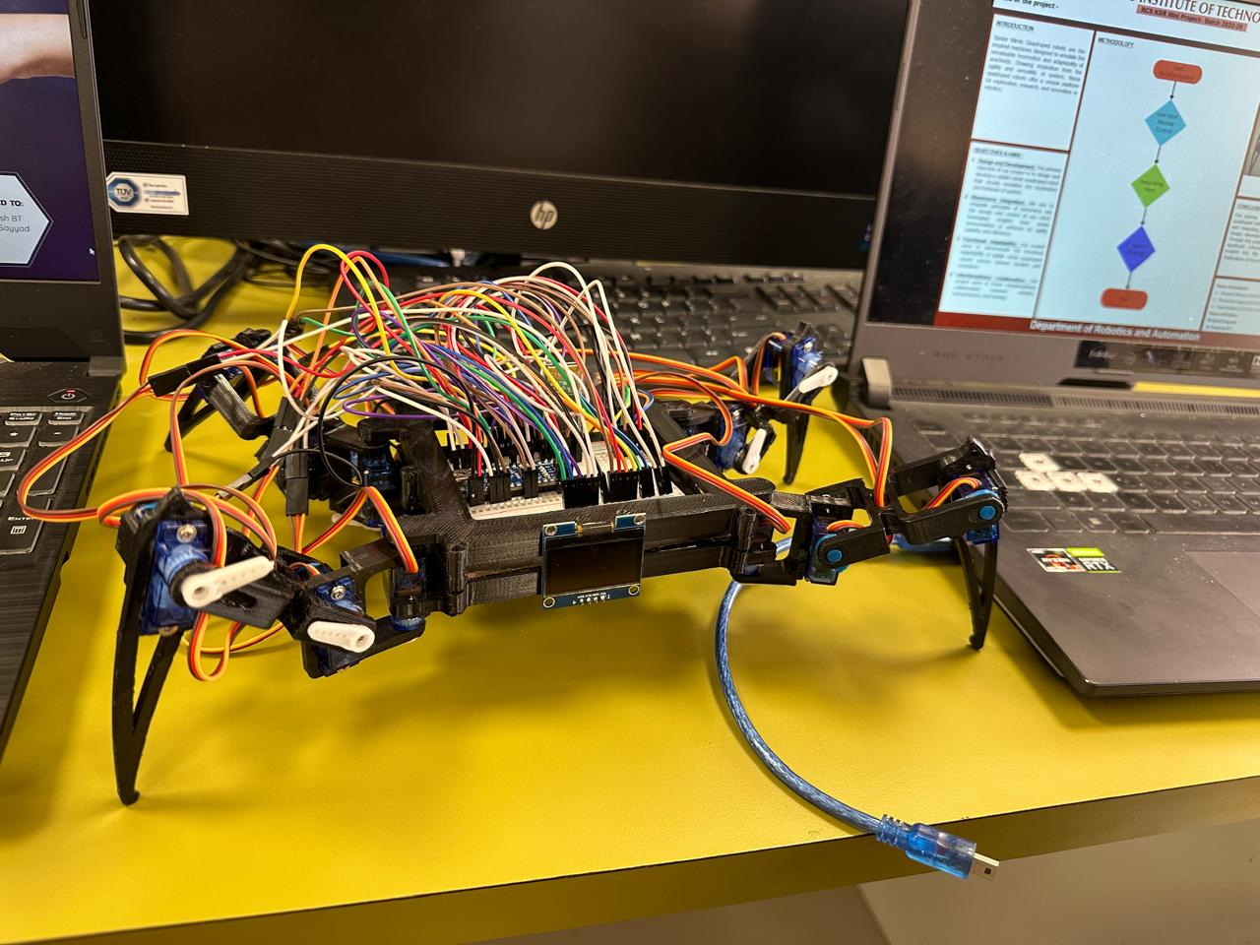

**RCS involved in your Mini Project**

Robot control systems in Arduino-based spider mimic quadrupeds play a crucial role in governing the movement and behavior of these innovative robotic creatures. These control systems are responsible for coordinating the actions of multiple limbs and ensuring smooth locomotion and agility, mimicking the movements of real spiders. Utilizing Arduino microcontrollers, sensors, and actuators, these control systems enable the spider mimic quadrupeds to navigate diverse terrains, respond to environmental stimuli, and perform complex tasks. The Arduino-based control systems typically incorporate algorithms for gait generation, sensor data processing, and motor control. Gait generation algorithms determine the sequence of leg movements required for locomotion, considering factors such as stability, efficiency, and adaptability to different surfaces. Sensor data processing involves interpreting input from various sensors, such as gyroscopes, accelerometers, and distance sensors, to make informed decisions about movement and navigation. Motor control algorithms translate these decisions into precise commands for the actuators, ensuring coordinated motion of the robot's legs. These control systems are designed to be versatile, allowing for customization and adaptation to specific applications and environments. By leveraging Arduino's open-source platform and a vast community of developers, enthusiasts, and researchers, advancements in robot control systems for spider mimic quadrupeds continue to push the boundaries of robotics, paving the way for new possibilities in exploration, surveillance, and assistance tasks.

**KDR involved in Mini Project:**

In Arduino-based spider mimic quadrupeds, kinematics and dynamics play fundamental roles in understanding and controlling the motion and behavior of the robotic creature. Kinematics deals with the study of motion without considering the forces causing it, focusing instead on aspects such as position, velocity, and acceleration. In spider mimic quadrupeds, kinematics algorithms calculate the trajectory and coordination of leg movements to achieve desired locomotion patterns, such as walking, crawling, or climbing. On the other hand, dynamics involves the study of the forces and torques acting on the robot and how they affect its motion. In spider mimic quadrupeds, dynamics algorithms model the interactions between the robot's body, legs, and the environment to ensure stability, balance, and efficient movement. This includes considering factors like inertia, friction, and gravitational forces to accurately predict the robot's behavior and optimize its performance. Together, kinematics and dynamics algorithms enable spider mimic quadrupeds to navigate complex terrain, adapt to changing conditions, and perform tasks with precision and agility. By implementing these principles in Arduino-based control systems, developers can create versatile and capable robotic platforms capable of exploring challenging environments, conducting surveillance missions, or assisting in search and rescue operations. Moreover, utilizing Arduino's user-friendly interface and extensive libraries, enthusiasts and researchers can experiment with different kinematic and dynamic algorithms to enhance the capabilities and versatility of spider mimic quadrupeds further.

1. **LITRATURE REVIEW**

**Biological Inspiration:** The concept of spider mimic quadruped robots draws inspiration from the remarkable locomotion and agility of spiders in natural environments. Spiders exhibit exceptional adaptability, navigating diverse terrains with ease and efficiency. Mimicking the biomechanics and behavioral patterns of spiders offers promising avenues for the development of agile and versatile robotic platforms.

**Biomechanics of Spiders:** The locomotion of spiders is characterized by a combination of leg coordination, adhesive mechanisms, and sensory feedback. Research in arachnid biomechanics has revealed the intricate coordination between multiple legs, allowing spiders to traverse complex surfaces with precision. Understanding the kinematics and dynamics of spider movement serves as a foundation for the design and control of spider-inspired quadruped robots.

**Robotics and Biomimicry:** Biomimetic approaches in robotics aim to emulate the efficiency and adaptability observed in natural systems. By replicating the morphology and locomotion strategies of spiders, researchers have developed innovative robotic platforms capable of navigating challenging environments. Spider mimic quadrupeds integrate advanced sensors, actuators, and control algorithms to emulate the agility and versatility of their biological counterparts.

**Legged Robotics:** Legged robots have garnered significant interest due to their potential applications in search and rescue missions, exploration of hazardous environments, and surveillance tasks. Spider mimic quadrupeds offer unique advantages over traditional wheeled or tracked robots, particularly in traversing uneven terrain, climbing vertical surfaces, and squeezing through narrow spaces. Recent advancements in legged robotics have focused on enhancing mobility, energy efficiency, and robustness through biomimetic design principles.

**Control and Coordination:** Achieving effective locomotion in spider mimic quadrupeds requires sophisticated control algorithms for leg coordination, gait generation, and terrain adaptation. Inspired by biological neural networks, researchers have developed decentralized control architectures capable of decentralized decision-making and adaptive locomotion strategies. Machine learning techniques, such as reinforcement learning and evolutionary algorithms, have shown promise in optimizing the locomotion performance of spider-inspired quadruped robots in real-world environments.

**Applications and Future Directions**: Spider mimic quadruped robots hold immense potential for various applications, including search and rescue operations, environmental monitoring, agricultural automation, and space exploration. Future research directions may focus on enhancing the agility, autonomy, and robustness of these robots through advancements in materials science, sensor technology, and artificial intelligence. Collaborations between roboticists, biologists, and materials scientists are essential for unlocking the full potential of spider mimic quadrupeds in diverse domains.

**Challenges and Limitations:** Despite significant progress, spider mimic quadruped robots face several challenges, including power efficiency, mechanical robustness, and sensory perception in complex environments. Achieving a balance between biomimetic design principles and engineering constraints remains a fundamental challenge in the development of spider-inspired robotic platforms. Addressing these challenges requires interdisciplinary research efforts and continuous innovation in robotics, biomechanics, and materials science.

1. **PROBLEM STATEMENT AND OBJECTIVES**

The objective of creating an Arduino-based spider mimic quadruped is to develop a versatile and agile robotic platform capable of emulating the locomotion and behavior of a spider. The key objectives of this project include:

1. **Locomotion Mimicry:** Designing a robotic system that replicates the leg coordination and movement patterns observed in spiders, enabling the quadruped to walk, crawl, climb, and maneuver through diverse environments with agility and adaptability.

2. **Sensor Integration:** Integrating various sensors such as gyroscopes, accelerometers, and distance sensors to provide feedback on the robot's orientation, velocity, and environment, enabling it to navigate autonomously and respond to external stimuli.

3. **Stability and Balance:** Implementing control algorithms to maintain stability and balance during locomotion, ensuring that the robot can traverse uneven terrain, slopes, and obstacles without tipping over or losing control.

4. **User Interface:** Developing a user-friendly interface using Arduino's programming environment and compatible software tools to facilitate ease of control, monitoring, and customization of the robot's behavior and performance.

5. **Educational and Research Purposes:** Creating a platform for education and research in robotics, biomechanics, and control systems, allowing students, hobbyists, and researchers to explore concepts such as kinematics, dynamics, and feedback control in a practical and hands-on manner.

1. **METHODOLOGY**

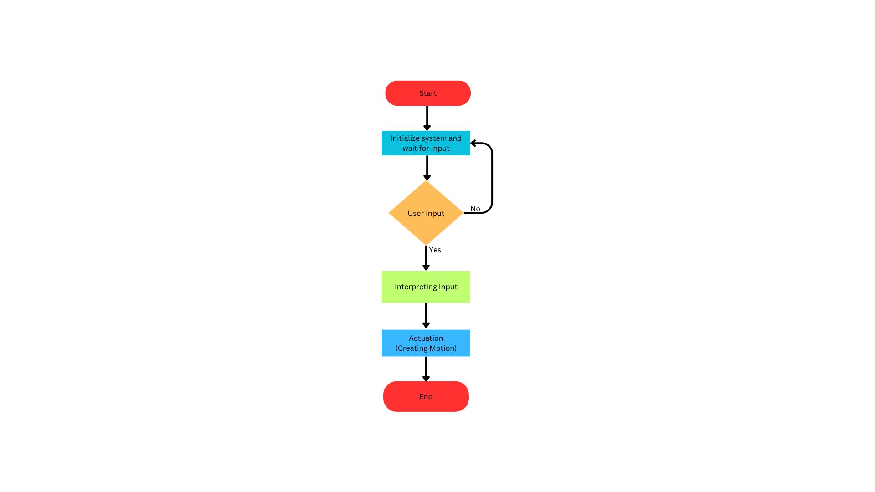

1. **RESULTS AND DISCUSSION**

**1. Performance Evaluation of Spider Mimic Quadruped Robot :**

The spider mimic quadruped robot was successfully designed, implemented, and tested in various scenarios to evaluate its performance. The following results were obtained:

**Agility and Versatility:** The robot demonstrated remarkable agility and versatility in navigating challenging terrains, including uneven surfaces, inclined planes, and obstacles. Its spider-inspired leg design allowed for smooth traversal and effective obstacle negotiation, showcasing the benefits of biomimetic locomotion.

**Terrain Adaptation:** Through real-time sensor feedback and adaptive control algorithms, the robot exhibited robust terrain adaptation capabilities. It could adjust its gait pattern and leg coordination to accommodate changes in surface conditions, such as rough terrain, loose gravel, and slippery surfaces, ensuring stable locomotion in dynamic environments.

**Climbing and Descending:** The spider mimic quadruped demonstrated exceptional climbing and descending abilities, emulating the vertical mobility of spiders. Its adhesive footpads, inspired by the natural adhesive mechanisms of spiders, provided secure attachment to vertical surfaces, enabling the robot to ascend and descend with ease.

**Obstacle Negotiation:** The robot effectively navigated through various obstacles, including barriers, gaps, and narrow passages. Its compact size and flexible body enabled it to squeeze through tight spaces and overcome obstacles that would impede traditional wheeled or tracked robots, highlighting the advantages of legged locomotion.

**2. Discussion :**

The results obtained from the performance evaluation of the spider mimic quadruped robot demonstrate its potential for diverse applications in robotics and automation. By leveraging principles of biomimicry and legged locomotion, the robot offers several advantages over conventional wheeled or tracked robots:

**Enhanced Mobility:** The spider-inspired leg design provides superior mobility and maneuverability, allowing the robot to navigate complex environments with agility and precision. Its ability to traverse uneven terrain, climb vertical surfaces, and negotiate obstacles expands its operational capabilities in real-world scenarios.

**Versatile Applications:** The spider mimic quadruped robot holds promise for a wide range of applications, including search and rescue operations, surveillance missions, environmental monitoring, and exploration tasks. Its compact size, agility, and adaptability make it well-suited for deployment in confined spaces, hazardous environments, and inaccessible areas where traditional robots face limitations.

**Interdisciplinary Collaboration:** The development of spider mimic quadruped robots necessitates collaboration between roboticists, biologists, materials scientists, and engineers. By drawing insights from biological systems and integrating advanced technologies, interdisciplinary research efforts can accelerate innovation and address key challenges in legged robotics.

**Future Directions:** Future research directions may focus on further enhancing the autonomy, efficiency, and robustness of spider mimic quadruped robots. Advancements in sensor technology, artificial intelligence, and materials science hold the potential to unlock new capabilities and applications for these bio-inspired robotic platforms.

1. **CONCLUSION**

In conclusion, the spider mimic quadruped presents an innovative and engaging platform for robotics enthusiasts to explore locomotion principles and wireless control technologies. By coordinating the actions of servo motors through the Arduino Nano, the robot can simulate the movements of a spider, providing an immersive and educational experience.

The integration of Bluetooth communication allows users to interact with the robot wirelessly, controlling its movements and adjusting parameters in real-time. This opens up opportunities for remote experimentation and collaborative learning, making the robot suitable for educational settings, hobby projects, and prototyping applications.

Furthermore, the modular design of the robot, facilitated by the breadboard and jumper wires, offers flexibility for customization and expansion. Users can easily add sensors, additional actuators, or advanced control algorithms to enhance the robot's capabilities and adapt it to different tasks and environments.

Overall, the spider mimic quadruped embodies the convergence of hardware and software technologies, providing a tangible platform for hands-on learning, experimentation, and creativity in the field of robotics. With its potential for exploration and discovery, this robot serves as a gateway to the exciting world of mechatronics and automation.

**REFERENCES**

<https://circuitdigest.com/microcontroller-projects/esp32-controlled-quadruped-spider-robot>

<https://github.com/angelicaortiz909/Spider-Robot-Arduino-Uno>

<https://www.hackster.io/diyguyChris/arduino-spider-robot-quadruped-57b832>

<https://www.khanacademy.org/science/electrical-engineering/robots/spider-bot/a/programming-spider>

<https://www.hiwonder.com/products/spiderbot?variant=32253242081367>

<https://www.hiwonder.com/products/spiderbot?variant=32253242081367>

<https://www.hackster.io/robotistan/quadrupped-spider-robot-with-arduino-063da5>

<https://www.flyrobo.in/blog/spider-robot-arduino>

<https://www.instructables.com/ARDUINO-SPIDER-ROBOT-QUADRUPED/>

<https://www.arduino.cc/>